The Historian Translator’s Voice in the Process of Translating the Analects into English:
An Interview with E. Bruce Brooks
倾听《论语》英译过程中历史学家的声音：汉学家白牧之夫妇访谈录
Youlan Tao Yan Wang E. Bruce Brooks A Taeko Brooks
陶友兰 王琰 白牧之 白妙子
Abstract: The Analects of Confucius, as a principal text within the Confucian tradition, has often been translated into foreign languages in the past 300 years. Are the translations well accepted and understood by English readers? The authors have made a survey among English readers and find that readers most often recommend The Original Analects: Sayings of Confucius and His Successors, translated by E. Bruce Brooks and A. Taeko Brooks. To investigate why this version was so highly regarded, Prof. Tao interviewed the Brookses in June 2019 on five topics: Why, How, What, For Whom, and To What End. According to the authors, their book is chiefly an explanation and not simply a translation. The historian translator’s task, as they see it, is to “try to make the translation itself as clear as possible, and then use the accompanying notes to provide the contextual information which the translation itself cannot be made to carry. This is why our book is called not only a translation, but also a commentary. The two together constitute our idea of “translation” – the carrying of a text across a cultural barrier.”
Key words: The Analects, Confucius, historian translator, commentary, historical context
关键词：《论语》，孔子，作为历史学家的译者，注疏，历史语境
WHY
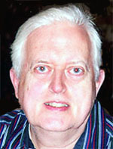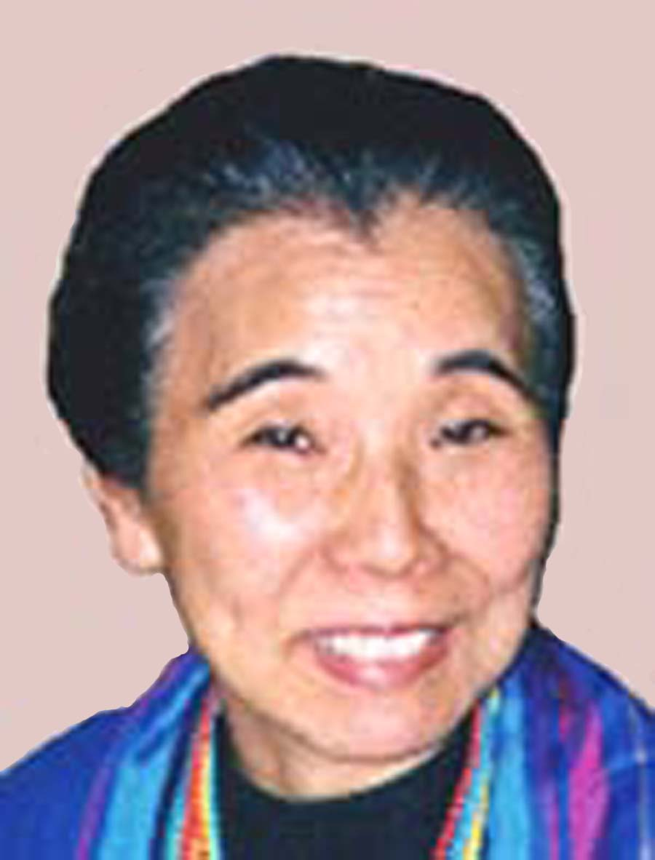
Q1: Good morning, Dr. Brooks. It is so nice of you to have a talk with us. As historians and Sinologists, you and your wife have translated the Analects in a different way from other English versions. Could you tell us in detail why you translated the Analects into English?
A1: Our project is to understand the Chinese Classical period, the Warring States and its precursor, the Spring and Autumn. The Warring States period, the formative age for all later Chinese history and thought, is represented by several dozen major texts. The task is to determine their chronological relationships, and the first step is to determine the character of the texts themselves. It seemed to us that the pioneering work on this question still left something to be accomplished. The first critical approach to the Analects was by Lyou Dzung-ywaen 柳宗元, in the Tang Dynasty, with further contributions from later Chinese and Japanese scholars, notably Tswei Shu 崔述 in the Ching Dynasty (to whom our book is dedicated) and in the West, by Arthur Waley, who took that line of thought a step further. (See our book, p201 and following). Our book is something like the endpoint of those centuries of analysis. Most of the Warring States texts are school compilations (as was seen by Tswei Shu’s contemporary Jang Sywe-chvng 章學誠): the record of a philosophical school over time, typically including some material by the school founder, plus later material added by his successors. The Analects, for example, is the text of the Confucian circle in Lu, beginning with some remembered sayings of Confucius, and continuing with new material written by his successors. My first report on the major classical texts was published in 1994 as "The Present State and Future Prospects of Pre-Han Text Studies" (Sino-Platonic Papers #46, 1-73). This considered the structure and date of a dozen texts: Analects, Gwandz, Mwodz, Mencius, Sundz, and so on. To see how these viewpoints argued with each other, and were influenced by each other, is to understand something of the intellectual history of the period. Our subsequent work has been to refine and extend that general insight. To see how the different schools reacted to the chief problem of the time – the trend toward total interstate war – is to begin to understand why these texts were saying what they did.
Of these twelve, we chose the Analects as the first text to be treated more fully, in part because of its importance in the history of Chinese thought, and in part because its long chronological span (230 years, from 0479 to 0249) covers most of the Warring States period, and thus provides an ideal platform from which to view the rise and development of the other schools. We hope to follow this up with studies of other major texts.
It was not the purpose of The Original Analects (Columbia 1998) to provide a translation as an end in itself (several competent English translations already existed, notably those of Legge, Lau, and Waley, plus the German version of Richard Wilhelm), but as a basis for explaining the thought of the text, and how it changed over time. We have been careful with the translation, and we naturally hope to have improved over previous efforts in several places (we have tried to follow the Chinese idiom more closely than is usual), But the main purpose was to show how these sayings arose, and what they meant in their own time.
What we offer to readers is the original form of the Analects. We identify its earliest chapter as LY 4, and then let the reader follow the text itself as it grows and changes over time. This shows us where Confucianism came from, what it was like, and how it evolved.
Our next book in the Sinological field will deal with the Dau/Dv Jing. For this, the Chinese text itself has to be reconstructed from the received (Wang Bi) version, the two Mawangdwei manuscripts, and the partial Gwodyen manuscript. This edited text will be a main feature of that book, whereas our Analects study did not include a Chinese text at all. The problems are different from those of the Analects, and the Dau/Dv Jing book will thus be different.
HOW
Q2a: How did you get to understand the Analects? Can you read it in Chinese?
A2a: I got to understand it by reading it, at first in English, and later in Chinese. Some general histories of China or of early Chinese philosophy, in both languages, were helpful as orientation.
Q2b: Did you refer to any commentaries on the Analects?
A2b: Yes. Some of them can be found in the “Works Cited” list at the back of the book, pages 315-323. But the commentaries have been of unequal value for our project. The early ones are often useful, but everything from the Sung dynasty onward reflects the thought of Ju Syi 朱熹, who had his own idea of Confucianism. To read the Analects through those commentaries is to study Sung thought. Instead, we wanted to understand the classical texts on their own terms.
I should add that some Japanese commentators have made good observations about the text: Ito Jinsai 伊藤 仁斎 in the 17th century; more recently Tsuda Sokichi 津田 左右吉 and others.
Q2c: Did you read other English versions during your work on the translation?
A2c: Not often during the actual translation process. We were already familiar with several English versions, but while doing our own, we preferred to work alone, to avoid the danger of unconscious imitation. We wanted to do our own best thinking, direct from the Chinese text. Now and then, at an especially hard place, we checked to see what others had done, thus adding their experience, for that moment, to ours.
I have the impression that the problem of previous translations is not much discussed in translation theory. Of several possible words in the target language, one will usually be more adequate than the rest; for example, “Heaven” for Tyen 天. If one translator adopts that good equivalent, then a later translator may be pardoned for doing likewise. So also, when a previous translator has an especially felicitous way of rendering a whole sentence, a later translator may properly accept that earlier solution. In this way, what I might call the community of translation gets better as it goes along. Of a passage in Dau/Dv Jing 30, translator Lin Yutang remarked, “These six lines are by Waley, for they cannot be improved upon.” So does one master acknowledge another. Attempts to avoid a good solution in some previous version (and this does happen) can easily lead to a grotesque and absurd new version.
Q2d: What academic papers on translating or studying the Analects have you read?

A2d: Arthur Waley's Notes on Translation (a BBC interview) appeared in his collection, The Secret History of the Mongols. He makes some good points, not about the Analects, but about other texts which he has translated, or knows of. Waley was a master, and there are few of his suggestions with which a careful reader, or conscientious translator, is likely to disagree.

Waley's Notes on Mencius, on some problems with Legge's Mencius translation, appeared in BSOAS and were included in the Hong Kong reprint of Legge's translations of the Chinese Classics. These are also suggestive for anyone approaching the Analects.

For the Analects, we carefully noted the suggestions of Stephen Durrant, On Translating Lun Yu, CLEAR v3 (1981).

Of my own publications on translation, the earliest was an article on Chinese and Japanese prosody in the Harvard Journal of Asiatic Studies, in 1975. It is available on the JSTOR archive, or here: http://www.umass.edu/wsp/project/staff/ebb%20prosodic.pdf

ALTA, the American Literary Translators Association, held a meeting at our university in the 1990's, before our Analects translation had gotten seriously under way. I gave a paper on what I saw as the fundamental principles of translation. That paper is available on our website:
http://www.umass.edu/wsp/lectures/translation/index.html

Taeko’s and my specific thoughts on translating the Analects came out in our review of the Burton Watson translation, made years after ours, but on different principles. It is available here:
http://www.umass.edu/wsp/resources/reviews/watson.html
Watson believes in bringing the Analects down to the level of what the average American undergraduate already knows. We feel that this diminishes the text and its potential value for precisely those undergraduates. If, as college students, they are not going to learn about another culture on its own terms, when do they plan to start?
Q2e: What are the biggest challenges you encountered in the process of translation?

A2e: There were some pleasant surprises. I had dreaded Chapter 10, the first thing written by the new ritualist leadership of the Confucian school, in the early 04th century. The reduplicative expressions (describing motions or attitudes) are famously opaque, and the whole atmosphere of bowing and scraping is stifling. But it was interesting to see just what the school leaders of that time thought it necessary to teach their students. Obviously, their students had no previous court experience; they had to learn how to bow, how to express respect with body motions and attitudes. A social transformation has taken place since the preceding chapter, LY 9. I was also surprised to see how much intellectual content there was, especially in the early chapters. The Confucians were thinkers. They wanted to teach how to distinguish right and wrong, and to use that skill in office. They did not want to be just tools in the hands of the ruler, but to exercise their own judgement.
The challenges were mostly external. Personal poverty is a problem, as many Chinese scholars over the centuries would probably agree. There was also something like organized opposition in the scholarly world. Our book got more than 30 reviews, a high number for so specialized a book, but the major journals in Europe and America did not take note of it. It seems that the idea of a growth text, a living document of human thought evolving over time, was not acceptable to many of our colleagues in the West. They wanted their Confucius to be always the same, and they wanted that one Confucius to be simple. They wanted a fortune cookie Confucius. It will be interesting to see how our work fares in its homeland, the country of Confucius and his followers, the country of Tswei Shu and other great scholars of the past.

Q2f: What translation method do you prefer when translating those concepts in h Analects that have no English equivalents?

A2f: There are two options: a transcription or a neologism. Either option creates a new word in the English dictionary, to be defined as best one can for future readers. We have used both options. One example is the key value in the early Confucian ideology: rvn 仁. Since its meaning changes over the course of the Analects, a single English translation will not serve. We have used “otherness” to explain the quality we think is common to the different historical meanings of rvn, but mostly have used the transcription. Legge’s term “benevolence” only works for the time of Mencius (that is, the time when LY 12-13 were written, the late 04th century). But that equivalent fails to capture the meaning of rvn for Confucius and his first followers, which was still close to the social origins of Confucius itself: the dedication of the serving officer, whether military or civilian. What we do, in war or peace, is not for us; it is for other people.

Q2g: What translation strategies (textual and extra-textual) do you think most appropriate to translate such a classic as the Analects?

A2g: That the Analects is a "classic" in its home culture merely makes it worth attending to; it does not otherwise affect the strategy of a translator. But the word “classic” does not mean the same thing for us as it did for Legge in 1854. For him, the Analects was “Chinese" - part of the native ideology which his missionary enterprise hoped to supplement or replace. It was in some sense an adversary. (I like Legge’s change of opinion in the second edition of his commentary, where he acknowledged that Confucius was “a very great man”). At present, and for about a century, the Analects (like the Mahabharata, or Tolstoy, or Shakespeare, or Homer, or Dante) is part of world culture; still a classic, but no longer an adversary. It is rather a cultural possession, the possession of a culture which is made up of readers in many countries. It is a world classic. As such, it is a known quantity outside China, and its difficulties have been, perhaps not always overcome, but recognized. The task of a new translator in this situation is not so much to introduce a novel text, or to define a strange term, as to deepen previous understanding of a work, or a word, which to some degree is already known.

The task of translation depends in part on the point which previous efforts have reached, about the text or the culture from which the text comes. Still, there will be some in every generation who are new to the work, and translators should consider them too. So though our Analects book had many predecessors, and our audience was partly an experienced one, we tried to make the translation itself as clear as possible, and used the accompanying notes to provide the contextual information which the translation itself cannot be made to carry. This is why our book is called not only a translation, but also a commentary. The two together constitute our idea of “translation” - the carrying of a text across a cultural barrier.

WHAT
Q3a: What about the Analects impresses you most?

A3a. There are two of us involved. Let me answer for Taeko. When she first met the Analects (in a graduate kambun 漢文 course, where Chinese texts are read in Japanese grammatical order), she was immediately impressed by LY 4: its strong sense of obligation to others, and its sense of duty. Precisely, rvn 仁 and yi 義. “It felt like coming home,” she told me. There is much of Confucian thinking in the Japanese tradition, which in its own way is close to the military ethos out of which Confucius himself came. That element in Taeko’s background prepared her to recognize more of Confucius than might the average Western reader.
But how did she recognize that this was the earliest chapter in the Analects? As a historian, Taeko has a central interest in aetiology: how things got to be the way they are. She is sensitive to the development of ideas, and thus to the point in the Analects at which that development began.
The best collaborators bring complementary skills to the work. Taeko’s previous study of the mediaeval Japanese manorial system gave her a feeling for administrative and economic factors which I do not equally possess. It turns out that the whole dynamic of the Warring States period derives from a transition from one administrative system (the palace state) to another (the bureaucratic state), and the accompanying economic change: exploiting the rural populace both for food production and as soldiers in the new mass army. To see this is to see the whole picture in its largest dimension. Without that insight of hers, there would be no book of ours.
So to answer for both of us: what most impresses us about the Analects is that it is a record of development extending over several centuries: a witness to the growth of the Chinese mind in its formative stage, and in its political as well as its philosophical aspects.

Q3b: Which verses do you think are the most difficult to understand/translate?

A3b: The Analects is not, by intention, a difficult text. The Dau/Dv Jing gives us riddles and paradoxes, things we have to puzzle out. But the Analects was meant to be understood. When Confucius says something cryptic, as in LY *4:15, a disciple in the same story will explain what he meant. The mention of sacrifices to “hills and streams” in LY 6:6 is obscure; we don’t have enough information about the popular rituals of the time to make sense of that situation, though the lesson Confucius draws from it is perfectly clear. The reduplicative expressions in LY 10, which describe the postures and attitudes of the courtier, are a mystery, and the characters with which they are written are no help, since they only indicate sounds; there is nothing to look up in the dictionary. But they were informative, to readers of that time, about the court etiquette which future courtiers had to internalize.

Q3c: What aspect of the Lunyu (ethical, literary, philosophical) did you want to focus on in your translation?

A3c: We didn’t have a particular focus. We were chiefly concerned with the historical context. There are many translations which re-interpret the text to make it relevant to modern living. We see that as a falsification. And why?? Because there are many modern situations, and thus many adaptations, no one of which has authority over any other. But there is only one Analects, which has its roots and its teachings in a particular past time and place. We wanted to get the placement right. We also feel responsible for getting the language right, and getting the style right. The philosophy of the text is only one of the things that this effort makes clear. (And it is not until the end of the 04th century that the concept of ”philosophy,” as a system of mutually coherent statements, appeared in China; see our p256).

Q3d: What different interpretations of the original text have you made or added in the process of translation? And why?

A3d: Hopefully, none. But we are aware of a value in the text that might deserve the attention of our contemporaries. Like much of classical Chinese thought, the stance of the Analects is public rather than individualistic. The Greek emphasis on eudaimonia, "personal well-being," as the highest good, which has been so influential in the West, is responsible for many of the shortcomings of Western civilization. To this, the classical Chinese concern for society at large can be a useful corrective. Of course that idea does exist in the West, but it lacks philosophical prominence. The Analects, as one text where the common good is constantly in view, thus has, in principle, much to offer to the present age. This was not our reason for translating it (we are historians, not political philosophers), but it is a valid consideration.
In our translation, we hope to have added nothing of substance, but we think our translation does get some things right, perhaps for the first time; chiefly the historical extent of the text, its witness, not to a philosophy, but to the evolution of a philosophy. It has been noticed that our translation is closer to the grammar, the word structure, of the original than others. And yes, we think we have sometimes understood grammatical constructions better than other translators. Or at least, we have tried harder than others to retain them as part of the rhetoric of the text - how it delivers itself; how it goes about persuading its intended hearers.

FOR WHOM

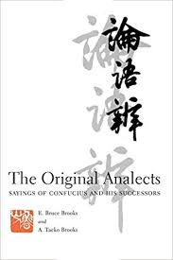

Q4a: Who are supposed to be the potential target readers of your translation? Why?

A4a: Our readers are principally scholars of Chinese civilization: the international community of Sinologists, but also professionals in other fields, such as political science, or history in general. There is probably only a small general readership for a text like the Analects (in contrast to the Dau/Dv Jing or the Yi Jing, which make their own way with modern readers), but we have tried to keep them in mind also. We have as far as possible avoided scholarly jargon. Whatever its readership, the book is still selling after 20 years. I think it is safe to say that despite considerable opposition, it has become (as your survey seems to reveal) something like a standard reference version of the Analects.

Q4b: What are your readers’ reading habits? Or expectations?

A4b: Reading as such is not flourishing at the present time. But in general: Scholars look for detail, general readers look for contemporary relevance. All readers appreciate clarity of expression and transparency of style. And all reviewers appreciate lack of typos - one reviewer pointed out that our book (typeset entirely by me, and printed by Columbia from my proof pages) contains very few typographical errors. I confess I am rather proud of that. On the other hand, readers of the book who see this may like to correct the following: Giradot > Girardot (p2), 698 > 798 (p110), not used > not to be used (p111), 0313 > 0314 (p125), posthumous > posthumous disciples (p289), 左求明 > 左丘明 (p333). For some other corrections and reconsiderations, including responses to reviews, see the Project website:
http://www.umass.edu/wsp/publications/analects/index.html

Q4c: What special adaptations for your potential readers have you made in the process of translation?
A4c: We made no conscious special concessions to the reader, preferring to present the text, as nearly as we could, on its own terms. We consider it to be the reader's share of the task of translation, to adapt to the sometimes unfamiliar cultural world of the book itself. Translation, for us, is a collaboration between the translator and the reader.

Q4e: How can we help more English readers understand or like to read the translated Chinese classics?

A4e: I think that the Chinese classics offer much to our modern world, as part of an increasingly international heritage. How to get people to take note of that possibility is another question, one which lies outside our abilities. All a translation can hope to do, it seems to me, is to make one part of that common heritage more readily available to those who may be interested in what it has to say. The rest of the work belongs to other people.

TO WHAT END
Q5a: Do you think the Analects has influenced your attitude towards Chinese culture or Asian philosophy? In what ways?

A5a: Our translation work was done after almost 40 years of study of classical China. At that point the Analects was not new to us; it was part of our background. But we hope that our previous study has enabled us to let the Analects speak more clearly to its modern readers.

Q5b: Could you share your opinion about the impact of the Analects on the study of Confucianism, Sinology, or even Western philosophy as a whole?

A5b: For the potential impact of the Analects on Western thinking, see above. In practice, Western philosophers seem reluctant to see any value in the Analects, or in any other nonwestern tradition. This is another problem which the translator should not be asked to solve.

Q5c: What are your suggestions for translating Chinese classics such as the Analects into English? Which factor will matter most?

A5c: There have been many schemes for translating Chinese texts systematically, some of them in China (Waley mentions the remarkable case of the early modern translator Lin Shu 林紓), some located elsewhere. I have my doubts about systematic approaches. UNESCO has a program to encourage the translation of significant works in any of the world’s literatures. I think that may be the most fruitful attempt so far, to make things happen in this area.

Yang Hsien-yi and Gladys Yang, with Lin Yutang and D. C. Lau, are essentially bilingual, even bicultural; their translations read very well. As for gaining a closer understanding of the specific historical past, that may be where efforts such as ours come in. If readers finish the Analects without realizing that the last few chapters come from a time centuries later than the first few, or that only in LY4 (and only in the first half of that) are they close to the historical Confucius, they have been ill served by their translation. As far as we can, we are trying to improve on that result.
At the present time, our translation has an odd sort of importance. There is currently a fad in the West for dating all the classical texts to the Han Dynasty, and denying them membership in the Warring States period. It has thus been suggested that the Analects is a Han compilation, not a Warring States text at all. This has been getting considerable attention, along with some opposition. As of this moment, it seems that our Analects study, with its careful argument for the accretional nature of the text, and for its close relation to the many strands of thought in the classical period, is one thing that stands in the way of the Han hypothesis. Reviews favorable to that hypothesis thus not only praise that idea, but target our work for abuse. The core issue is whether the Analects has the structure of an accretional text: one which grew over time.
Our translation, which separates the Analects into twenty formation layers, was always likely to be unwelcome to the average reader, whether Chinese or Western. We are thus amused to find ourselves in the position of defending one aspect of the traditional understanding of the text, against the current Han hypothesis.

Tao: Thank you so much for your detailed answers to our questions. Your words seem to me both informative and inspiring. As a historian translator, you have demonstrated your unique focus and contribution to the understanding of the Analects. It is no wonder that your book has a large readership. Your critical understanding of the classical texts, your bold hypothesis and detailed arguments concerning its formation, have surely enriched Sinological studies in general, as well as studies of Confucianism in particular. You mentioned the concept of “the community of translation” and as a scholar of translation, I quite agree with you. For the translations of works previously translated, translators may validly share some established “good and accurate” expressions. You also said that the Analects does not belong only to China; it is universal. This entirely accords with the ultimate goal of translation as I understand it.
Brooks: Thank you for your interest. We have given our lives to reaching a more adequate understanding of the ancient world, and it is nice to have this opportunity to share, not only our results, but our ideas about the way one does this kind of history, and its place in the larger project of increasing mutual understanding in the modern world.

Notes on the contributors and authors:
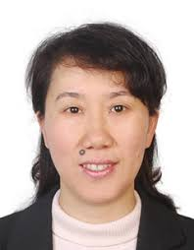
Youlan Tao is a Professor at Fudan University in China. She is completing a Fulbright year at Kent State University in the USA, on academic readers’ responses to English translations of the Analects of Confucius. After conducting a survey among English readers, she finds that a majority would recommend The Original Analects: Sayings of Confucius and His Successors, published by Columbia University Press in 1998. The translators are E. Bruce Brooks and A. Taeko Brooks. To investigate why this version was so highly recommended, Prof. Tao interviewed Bruce Brooks in June 2019 on five topics: Why, How, What, For Whom, and To What Effect.
Yan Wang (Vivian) is an Associate Professor at the University of Science and Technology Beijing in China. Her dissertation was on English translations of the Analects in Western Sinology. She is currently translating Bruce and Taeko’s book into Chinese. Together with Prof. Tao, Prof. Wang contributed some questions about the process of translating. This interview, then, is a meeting place between translators and researchers.
E. Bruce Brooks is the Director of the Warring States Project, founded in 1993 at the University of Massachusetts at Amherst. He obtained his MusB from Oberlin Conservatory in 1958, and his PhD from the University of Washington in 1968. He holds the rank of Research Professor, and also serves as an Adjunct Professor in the Department (now, Program) in Asian Languages and Literatures at the University.
A. Taeko Brooks, co-author of The Original Analects, is Research Associate at the Warring States Project. She obtained her AB in history in 1958, and her MA in 1961, from the University of Hawaii. She studied in the PhD program at the University of Washington in 1961-1964.
More information at http://www.umass.edu/wsp/project/staff/atbrooks.html

联系方式：
陶友兰：复旦大学教授，翻译系副系主任, 从事翻译研究
通讯地址：上海市杨浦区邯郸路220号复旦大学外文学院 200433
电话：13671600660，taoyoulan@fudan.edu.cn

